CANDIDATE BRIEF
Farm Manager – Estates and Facilities Directorate

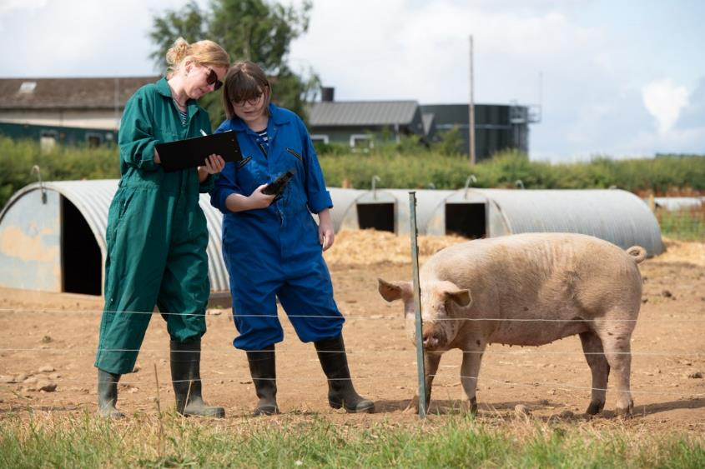

Salary: £40,792 to £48,677 – per annum (University Grade 8)
Hours: Full time - No fixed hours - including some weekend working
Holidays: 25 days per annum plus Bank Holidays
Pension: University Superannuation Scheme (USS)

Research Farm Manager
Estates and Facilities Directorate

Are you a professional Farm Manager with significant experience in pig farming and an interest in managing an expanding, state-of-the-art, pig unit that supports the University’s research developments?
The University of Leeds has an Agricultural Estate comprised of 317 hectares, located 12 miles from Leeds, to the west of Tadcaster. The estate supports academic research and teaching, as well as being a commercially operated arable and pig farm that hosts research and innovation projects.
The business which is managed by a farm management company, is now seeking to appoint its own experienced Farm Manager to directly manage the pig side of the business as well as operating as the University’s first point of contact for the arable contractor.
The pig farm is rapidly expanding its role as a research facility, with an £11m investment in both indoor and outdoor pig production facilities to create the main pig research centre within the Centre for Innovation Excellence in Livestock (CIEL).
The new indoor facility, currently under construction, will be a farrow to finish unit of 440 sows equipped with state of the art feeding equipment and other innovations to support the University’s pig research programme. The site also maintains a 220 sow outdoor unit. To head up these new facilities, we require an experienced pig farm manager with specific experience of indoor pig production.
You will be responsible for the efficient running of the pig farm within the requirements of its core purpose as a centre for research, development and teaching - whilst maintaining a commercial aspect.
You will also work on behalf of the Director of Estates and Facilities Management, together with the farm management company to support ongoing development of the wider farm estate to ensure it can operate effectively, including identifying opportunities for income generation as well as to ensure the farm operations are sustainable, ensuring that the farms are run under best practice, being a beacon of good practice and innovation.

What does the role entail?

As the Farm Manager your main duties will include:

- Ensuring the farm facilities are managed effectively, well maintained and meet the needs of the research community whilst achieving commercial success.
- Responsibility for liaison with academic researchers (pig and arable)to ensure that operational needs are met;
- Responsibility for the day to day operation of both the indoor and outdoor pig units,
- Responsibility for effectively developing, leading and managing an expanding team of pig farm staff and ensuring resources are deployed efficiently across the indoor and outdoor units as necessary;
- Managing the expansion of the indoor pig unit and the move to the new building.
- Responsibility for working in partnership with research and teaching staff across the University to facilitate state of the art research; whilst also ensuring the delivery of a sustainable working farm estate.
- Responsibility for all agricultural, environmental and Health & Safety compliance, permits and accreditations;
- Responsibility for ensuring the pig farm is operated in a safe and well maintained way, ensuring appropriate processes are developed and implemented to ensure both statutory compliance and best practice are followed;
- Responsibility for liaising, on behalf of the University, with the arable farming contractor;
- Responsibility for effectively managing relationships with key suppliers, consultants and customers of the farm;
- Responsibility for effectively preparing and managing all budgets for the farm to maximise income from farm operations, whilst ensuring adherence to University of Leeds finance and procurement processes and procedures.

These duties provide a framework for the role and should not be regarded as a definitive list. Other reasonable duties may be required consistent with the grade of the post.

What will you bring to the role?

As Farm Manager you will have:
- Substantial experience of managing a farm or farm estate;
- Significant experience of working in pig farming / production; including indoor pig units;
- Confidence in using up to date technology and an understanding of the need for accuracy and attention to detail to ensure the integrity of research activity;
- Commercial awareness, with the ability to effectively negotiate and manage supplier contracts;
- Extensive experience of building effective working relationships using strong interpersonal and communication skills
- The ability to communicate with a range of people within both the farming and academic communities;
- The ability to exercise initiative and proactivity with evidence of a problem solving, “can-do” and non-bureaucratic approach;
- The ability to work effectively and collaboratively within a team, as well as the ability to work on own initiative to make independent decisions;
- Excellent organisational skills with an ability to prioritise competing demands and work under pressure in a busy environment to meet strict deadlines
- The ability to lead, develop and manage a team of staff in a working farm;
- Hold a full UK driving licence.

You may also have:
- Experience of working in Higher Education or within agricultural research.

Additional information

Accommodation
Accommodation will be made available for the successful candidate on the farm site.

Candidates with disabilities
Information for candidates with disabilities, impairments or health conditions, including requesting alternative formats, can be found on our Accessibility information page or by getting in touch with us at disclosure@leeds.ac.uk.

Criminal record information

Rehabilitation of Offenders Act 1974
A criminal record check is not required for this position. However, all applicants will be required to declare if they have any ‘unspent’ criminal offences, including those pending.

Any offer of appointment will be in accordance with our Criminal Records policy. You can find out more about required checks and declarations in our Criminal Records information page.

