

**CANDIDATE BRIEF**

Course Design Manager, Digital Education Service

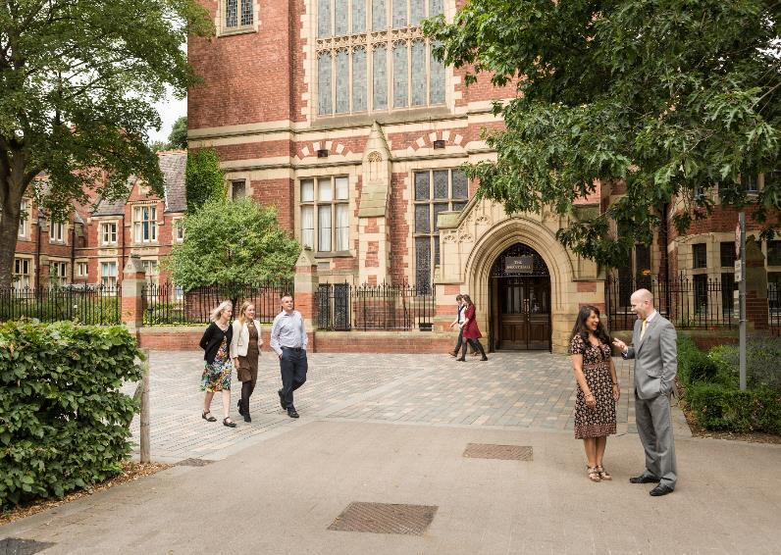

Salary: Grade 7 (£33,797 – £40,322 p.a.)

Reference: CSDLS1058

Fixed term for 2 year due to funding

We will consider flexible working arrangements

Course Design Manager

Digital Education Service

Can you work with subject matter experts to design innovative learning opportunities? Do you have proven experience of managing a team to produce quality courses based on sound pedagogical principles?

You will work with the Digital Education Service (DES), subject matter experts and external stakeholders to design and oversee production of high quality, professional and innovative learning for online and blended learning courses. All learning development will be in line with the vision and ethos of the University and the University’s Digital Learning and Blended Learning strategies. Courses will be available to University of Leeds students, external stakeholders or the general public, all with a wide range of interests and learning expectations, and on platforms such as FutureLearn, and the University’s internal virtual learning environment (VLE),

Working closely with all members of the DES, you will support the management of the team and lead the day-to-day activity of a team of course developers.

You will have excellent communication and organisational skills and experience of the professional and timely delivery of multiple, concurrent production projects preferably within an online learning environment.

**What does the role entail?**

As a Course Design Manager your main duties will include:

* Overseeing and managing the day-to-day activities of DES content team members, taking responsibility for the quality of outputs;
* Working with the team, subject matter experts and other stakeholders to design pedagogically robust, quality-assured online and blended learning journeys, e-learning activities and assessment models interactive learning experiences and robust collaborative learning opportunities;
* Managing content and course production in liaison with team members, external production companies and other stakeholders, ensuring that the functionality is in line with the instructional design principles;
* Working with external and internal learning platforms, including day-to-day liaison with platform representatives;
* Supporting the professional development of DES team members;
* Ensuring compliance with relevant University policies such as those defining social media, digital strategy, design, accessibility, copyright and Intellectual Property standards.

These duties provide a framework for the role and should not be regarded as a definitive list. Other reasonable duties may be required consistent with the grade of the post.

**What will you bring to the role?**

As a Course Design Manager you will have:

* A University degree level qualification or another relevant qualification or professional experience;
* Proven experience of instructional or curriculum design for an online environment;
* Experience of applying up-to-date knowledge of sound instructional design principles in an educational environment;
* Experience of working with a wide range of learning technology platforms, learning management systems, tools and services;
* The proven ability to maintain and develop effective working relationships with subject matter experts, external partners and other stakeholders;
* Proven experience of managing teams to perform and deliver to a consistently high standard, with the ability to motivate and develop team members;
* A strong command of the English language with proven ability to review, edit and quality assure content to ensure suitability for the online learning environment;
* The ability to plan your own workload, make decisions about priorities and meet deadlines without compromising quality in a challenging and fast moving environment;
* Proven experience of managing a number of projects concurrently to strict time scales and defined budgets;
* A clear understanding and awareness of accessibility and copyright issues;
* Excellent presentation, interpersonal and communication skills;
* Experience of working collaboratively as part of a team.

You may also have:

* An MA in an education-related field, PGCE or relevant training qualification;
* Experience of supporting academic work in higher education.

**How to apply**

You can apply for this role online; more guidance can be found on our [How to Apply](https://jobs.leeds.ac.uk/display.aspx?id=1253&pid=0) information page. Applications should be submitted by **23.59** (UK time) on the advertised closing date.

**Contact information**

To explore the post further or for any queries you may have, please contact:

Angela Holmes, Digital Education Manager

Tel: +44 (0) 113 343 9714

Email: [A.E.Holmes@leeds.ac.uk](mailto:A.E.Holmes@leeds.ac.uk)

**Additional information**

**Working at Leeds**

Find out more about the benefits of working at the University and what it is like to live and work in the Leeds area on our [Working at Leeds](https://jobs.leeds.ac.uk/display.aspx?id=1697&pid=0) information page.

**Candidates with disabilities**

Information for candidates with disabilities, impairments or health conditions, including requesting alternative formats, can be found on our [Accessibility](https://jobs.leeds.ac.uk/display.aspx?id=1253&pid=0) information page or by getting in touch with us at [disclosure@leeds.ac.uk](mailto:disclosure@leeds.ac.uk).

Criminal record information

Rehabilitation of Offenders Act 1974

A criminal record check is not required for this position. However, all applicants will be required to declare if they have any ‘unspent’ criminal offences, including those pending.

Any offer of appointment will be made in accordance with our Criminal Records policy. You can find out more about required checks and declarations in our [Criminal Records](https://jobs.leeds.ac.uk/display.aspx?id=1711&pid=0) information page.