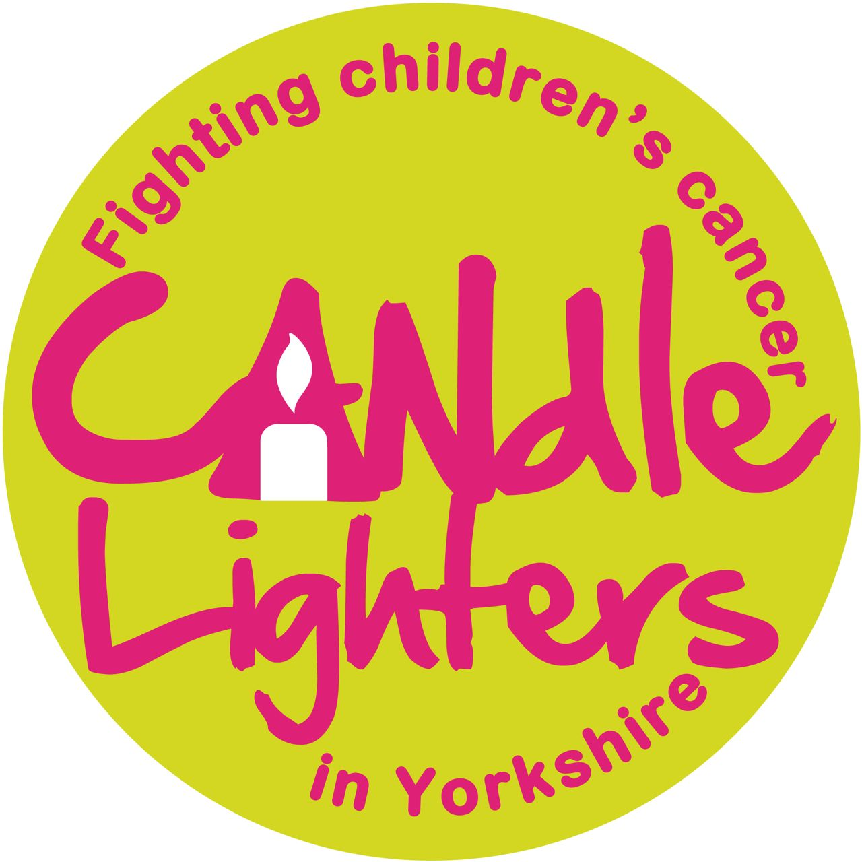

Faculty of Medicine and Health
School of Medicine
Leeds Cancer Research UK Centre

Candlelighters Clinical Research Fellowships (1 post available in 2015)

The University of Leeds, which is part of The Cancer Research UK Leeds Centre, is in receipt of support for 5 Clinical Research Fellowships to run concurrently over a 6-year period; 1 of these posts is currently available. Candlelighters fund these fellowships, which will support outstanding clinicians in training to obtain training in research.

Applications are sought from clinicians who are committed to academic careers relevant to paediatric/teenage and young adult oncology or malignant haematology, with the potential to be leaders in their field. We are seeking an outstanding individual who wishes to pursue a period of full-time research. Applications are welcome from exceptional candidates wishing to work towards a PhD (3 years) or MD (2 years).

You will work within the University of Leeds, which has state-of-the-art laboratory, clinical, epidemiology and health service research facilities.

Applicants will be medically qualified; GMC registered and should preferably be a Member/Fellow of a UK Royal College. Experience in laboratory-based or clinical research is not essential, as appropriate training will be provided as necessary. Candidates will, however, be expected to display an enthusiasm for learning relevant new research techniques. When completing their application candidates will be expected to state their preferences amongst a list of projects available from Paul Affleck, email p.a.affleck@leeds.ac.uk .

The post is for a fixed term of up to three years and will be based at St James’s University Hospital. You will be expected to participate in the structured clinical research training programme. A scientific and a clinical supervisor will support you.

For further information on our outstanding research facilities, please visit:
http://medhealth.leeds.ac.uk/licap
http://medhealth.leeds.ac.uk/info/500/leeds_institute_of_cardiovascular_and_metabolic_medicine
http://medhealth.leeds.ac.uk/info/600/leeds_institute_of_health_sciences/
http://www.leedsth.nhs.uk/a-z-of-services/childrens-and-adolescent-oncology-and-haematology/
www.cancerresearchukcentre.leeds.ac.uk
http://www.leedsth.nhs.uk/home

The University of Leeds is committed to providing equal opportunities for all and offers a range of family friendly policies (http://hr.leeds.ac.uk/homepage/4/policies). The University is a charter member of Athena SWAN and holds the Bronze award. The School of Medicine gained the Bronze award in 2013. We are committed to being an inclusive medical school that values all staff, and we are happy to consider job share applications and requests for flexible working arrangements from our employees.

Clinical Research Fellow (£31,301 to £47,175 p.a.) depending on qualifications and relevant experience.

For informal enquiries, please contact:
Professor Sally Kinsey sally.kinsey@nhs.net 0113 392 8191 or,
Dr Adam Glaser adam.glaser@nhs.net 0113 392 8779

If you have any specific enquiries about your online application please contact Sharon Collins tel. +44 (0) 113 206 6949 email s.collins@leeds.ac.uk

Job Ref: MHCAP1031 Closing Date: 14 August 2015
Background

The University of Leeds, with support from Candlelighters, has developed a programme of cancer research fellowships with relevance to malignant disorders in young people. The scheme supports trainees at an early stage in their research careers in paediatric/TYA cancer-related disciplines (paediatric, medical and clinical oncology, surgery, pathology and others) that have shown a commitment to, and talent for, high-quality research. The Fellowships are intended to make an important contribution towards career development in paediatric/TYA cancer research.

Support is available for up to 3 years for laboratory-based or clinical research in a paediatric/TYA cancer-related discipline leading to a PhD or MD.

Fellowships will be based in state-of-the-art laboratories at the University of Leeds and/or in magnificent clinical facilities in either the St. James’s Institute of Oncology on the St James’s University Hospital Campus of the University of Leeds or the paediatric and TYA facilities at the Leeds General Infirmary. Supervision of Fellows will normally be carried out by a minimum of two senior supervisors, at least one of whom will be a clinical researcher in a paediatric/TYA cancer-related discipline. Collaborative links and rotations for specific scientific and training purposes will be encouraged across Leeds, the United Kingdom and internationally.

There is a list of topics with appropriate research supervisors available from Paul Affleck (email P.A.Affleck@leeds.ac.uk) with accompanying abstracts. Candidates are encouraged to discuss the projects they are interested in with the appropriate supervisors prior to interview. Short-listed candidates will be asked to express a preference for a particular project at interview. The Scientific Committee, including at least one external reviewer, will select the best candidates while ensuring that they are able to work in the preferred area and that the combination of candidate, project and supervision is of the highest quality.

Main Duties & Responsibilities

Research

- Conducting a high-quality research project in a paediatric/TYA cancer-related discipline.
- Taking responsibility for the day-to-day running of your study.
- Presenting research data at a local and international level and contributing fully to the activities of the multidisciplinary team.
Other duties and responsibilities will be agreed by the supervisors and the Scientific Committee.

Teaching

Although no formal teaching requirements will be made of Fellows, they may be expected to share in these tasks on an occasional basis.

Training

A rolling training programme will be provided to support acquisition of a broad knowledge base in basic scientific, translational and applied health services research, epidemiology and biostatistics. This will consist of a weekly programme of Fellows’ tutorials and training activities including journal club.

Clinical Duties

The intention of the funding is to provide the opportunity to concentrate fully on performing high-quality cancer research. However, it is recognised that it is important for Fellows to perform a small amount of clinical work. This will not exceed 10% of their time, on an annualised basis, except in exceptional circumstances, and in agreement with their supervisors and the Programme Directors (Sally Kinsey/Adam Glaser).

General

- To play a role in the wider life of paediatric/TYA cancer research in Leeds, including public and patient engagement activities.
- To carry out the duties of the post in accordance with the University values and standards in line with University policies and procedures and local faculty/school benchmarks as appropriate.
- To maintain a safe work environment, including ensuring compliance with legislation and the undertaking of risk assessments.
- To maintain own continuing professional development.
- To integrate the University value of inclusiveness into all appropriate aspects of the job; respecting the dignity and diversity of all members of the University community and of visitors to the University.

Relationships

You will be responsible to a clinical and a non-clinical supervisor, through them to the Programme Directors (Sally Kinsey/Adam Glaser) and the Scientific Committee, through whom they will be accountable to the Dean of the School of Medicine and Faculty of Medicine and Health. You will be expected to work with other members of the Unit to ensure good teamwork and efficient day-to-day running.

University Values

All staff are expected to operate in line with the university’s values and standards, which work as an integral part of our strategy and set out the principles of how we work together. More information about the university’s strategy and values is available at http://www.leeds.ac.uk/comms/strategy

Person Specification

Essential:

- Medically qualified with suitable clinical experience
- GMC registered
- Motivated, with a keen interest in paediatric/TYA oncology or malignant haematology research, with a desire to undertake a higher research degree (PhD or MD)
- Display an enthusiasm for learning appropriate new research techniques
- Evidence of potential to become an outstanding paediatric/TYA cancer researcher
- A capacity for original thought that will enable you to develop an individual research interest
- Effective interpersonal and communication skills
- Competent computing skills and an awareness of information technology

Desirable:

- Preferably a Member/Fellow of one of the Royal Colleges
- Previous experience in laboratory-based or clinical trials research (training will be provided if necessary)
- An understanding of literature searching techniques and statistics
- Evidence of an ability to organise own work and to meet deadlines

It is expected that a high proportion of research performed during the Fellowship will contribute to the award of a higher degree.

Professional Registration

As a qualified doctor you should obtain periodic registration with the GMC. You will be required to maintain such registration so long as you remain employed with the University Of Leeds, confirming to your line manager that renewal has been carried out as required by the relevant professional organisation. You should produce documentation giving evidence of your registration upon request.

Further Information

Paediatric and teenage and young adult oncology and haematology research in Leeds

The St James’s Institute of Oncology and Department of Paediatric Oncology and Haematology have a leading profile in the delivery of comprehensive clinical research programmes with prominent roles in the delivery of national initiatives played by members of the clinical teams (including the National Cancer Research Network and National Cancer Research Institute).

Paediatric Haematology and Oncology Research in Leeds
The Paediatric Haematology and Oncology Department at the Leeds Teaching Hospitals NHS Trust has a strong research portfolio that has developed over the last 30 years. This has directly impacted on the delivery of health care and the quality of outcomes from cancer through the provision of innovative research projects and training of clinicians in relevant academic disciplines. There has been a successful association with the University of Leeds, much of which has been supported by Candlelighters. Clinical training research fellows have successfully obtained MDs and PhDs with funding from a variety of sources including CRUK, MRC, Yorkshire Cancer Research, Candlelighters and Jeremy Neill Allen Fund.

Yorkshire Children’s and Young Adult’s Cancer Registry
Collaboration with the University of Leeds, Department of Epidemiology commenced in 1974. This led to the establishment of one of the principle population-based childhood cancer registers, the Yorkshire Children’s Tumour Registry. More recently this has widened to become the Yorkshire Children’s and Young Adult’s Cancer Registry (CYACR) recording and following up malignant diseases diagnosed in individuals up to the age of 30 years. From the conception of this valuable resource Candlelighters has provided financial support contributing to running costs, funding salaries and support to specific research projects. Work programmes have supported hypotheses generated by the clinical teams in Leeds and have enabled paediatric oncology/haematology trainees and consultants to further their understanding of these areas. Recent projects have included the analysis of outcome of children with malignancies, ethnic and socio-economic differences in incidence and outcome from childhood malignancies, modelling of disease incidence, seasonality of presentation and mobility of cancer survivors. Grant income from multiple sources, including Cancer Research UK (CRUK), support the grants from Candlelighters.

Candlelighters Children’s Cancer Research Laboratory
In 1991, following a specific fund-raising initiative, the Candlelighters Children’s Cancer Research Laboratory was opened in the Cancer Research Building on the St James’s Hospital site. Candlelighters provided capital investment for the fabric of the laboratory, funding for a scientific research lead (Professor Sue Burchill) and initially on-going infrastructure costs. Close collaboration between medical staff in paediatric haematology and oncology and Candlelighters laboratory scientific staff has led to very successful development of the laboratory and its staff which is internationally recognised for the calibre of its research. Specific research projects both by laboratory scientists and medical researchers have led to MD and PhD theses with particular themes in rhabdomyosarcoma, Ewing’s tumours, neuroblastoma and PMS gene mutations.

Brain Tumour Research Laboratory
Yorkshire’s only laboratory devoted to brain tumour research was launched at the University of Leeds in 2011. The laboratory, based at the Leeds Institute of Cancer and Pathology is supported by two local charities, Candlelighters and Brain Tumour Research and Support (formally Andrea's Gift).

Fertility Preservation
Successful collaborative work with the reproductive biology unit (Prof H Picton) has facilitated work in the area of in vitro maturation of oocytes and furthering understanding of the impact of cancer treatments on female fertility.

Cancer Research UK Leeds Centre

The Cancer Research UK Leeds Centre supports and promotes cancer research within Leeds. Part of its remit is to collaborate with other local funders, and to involve and engage local patients and the public. It has been renewed for 2014-2017. The Centres are one of Cancer Research UK’s highest priority initiatives and play a major part in its five year strategy

http://www.cancerresearchuk.org/funding-for-researchers/how-we-deliver-research/our-research-strategy

They form a national framework through which the charity can deliver the greatest impact in the global fight against cancer.

Faculty Information

Faculty of Medicine and Health Information
With more than 6,000 students, 1,600 staff and annual research income of £60m, the Faculty of Medicine and Health at Leeds is bigger than some universities. Leeds has one of the largest medical and bioscience research bases in the UK, and is an acknowledged world leader in cancer, cardiovascular, psychiatric, genetic, musculo-skeletal and health services research. Treatments developed in Leeds are transforming the lives of people around the world living with conditions such as HIV, TB, diabetes and malaria.
The School of Medicine
The School of Medicine at the University of Leeds is a major international centre for research and education. Our ambition is to improve health and reduce health inequalities, locally and globally, through excellent scientific research and the translation of that research into healthcare practice, and through the education of future scientific and clinical leaders who will advocate and practise an evidence-based approach. Our major strategic aims are to:
- Deliver outstanding research including basic discovery science through to applied health research that makes a significant difference to health.
- Produce exceptional graduates, clinicians, educators, doctoral and post-doctoral fellows whose learning has been informed and inspired by our research excellence and who will form the next generation of academic and clinical leaders.
- Develop and support knowledge transfer activities that flow from our academic activities.
- Create and maintain an efficient and sustainable environment for research and teaching within an organisational culture and management style that enacts and supports the university’s core values of community, inclusiveness, integrity and professionalism.
The School of Medicine is organised into seven Institutes. All are committed to high quality research-led teaching, through their training of postgraduate research students, delivery of postgraduate taught courses, and its leadership in undergraduate teaching. The School works closely with the local NHS, having a number of jointly funded clinical posts to ensure this relationship is effective and strong for both research and student education.
Terms and Conditions
Details of the terms and conditions of employment for all staff at the university, including information on pensions and benefits, are available on the Human Resources web pages accessible via the links on the right hand side, or at http://hr.leeds.ac.uk/policies

Disclosure and Barring Service Checks
This post falls under the remit of the Rehabilitation of Offenders Act 1974 (Exceptions) Order 1975. As such, all applicants are required to declare any convictions, cautions, reprimands and warnings, including any pending criminal prosecutions and those which would otherwise be considered 'spent' under the 1974 Act. However, amendments to the Exceptions Order 1975 (2013) provide that certain ‘spent’ convictions and cautions are now 'protected' and are not subject to disclosure to employers , and cannot be taken into account. Guidance and criteria on the filtering of these cautions and convictions can be found on the Disclosure and Barring Service website. https://www.gov.uk/government/organisations/disclosure-and-barring-service and at http://www.legislation.gov.uk/uksi/2013/1198/pdfs/uksi_20131198_en.pdf

Declarations of any such information as described above, should be made in the ‘other personal details’ section of the application form and details sent to the Recruitment Officer at disclosure@leeds.ac.uk.

Enhanced Disclosure from the Disclosure and Barring Service (DBS) is required for this position. The successful applicant will be required to give consent for the University to check their criminal record status through independent verification (from the DBS). Information will be kept in strict confidence. Your offer of appointment will be subject to the University being satisfied with the outcome of these checks.

Disabled Applicants

The post is located in various locations across the St James’s Hospital site. Disabled applicants wishing to review access to the building are invited to contact the department direct. Additional information may be sought from the Recruitment Officer, email disclosure@leeds.ac.uk or tel + 44 (0)113 343 1723.

Disabled applicants are not obliged to inform employers of their disability but will still be covered by the Equality Act once their disability becomes known.

Further information for applicants with disabilities, impairments or health conditions is available in the applicant guidance.

