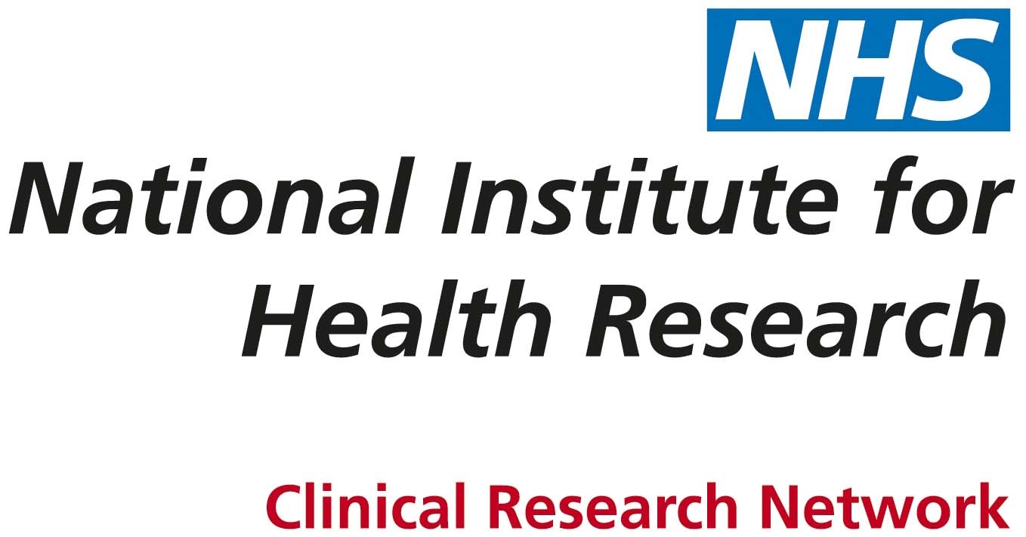

Corporate Operations Directorate
Integrated Governance Officer

The National Institute for Health Research Clinical Research Network Coordinating Centre is a hosted organisation provided through a partnership of:

• Guy’s and St Thomas’ NHS Foundation Trust
• Imperial College London
• King’s College London
• Newcastle University
• PA Consulting Group
• University of Leeds
• University of Liverpool

National Institute of Health Research, Clinical Research Network Coordinating Centre Faculty of Medicine and Health/Guy’s and St Thomas’ NHS Foundation Trust

Integrated Governance Officer 1.0 FTE
This post is available open ended fixed funded until 31 March 2020

Do you enjoy working as part of a team and want a role that provides a varied workload together with additional elements such as project work? We are looking for an experienced and enthusiastic Integrated Governance Officer to join the Integrated Governance Team, part of the Corporate Management and Governance function.

Corporate Governance is the way in which organisations are directed, controlled and led. It defines relationships and the distribution of rights and responsibilities among those who work with and in the organisation. It determines the rules and procedures through which the organisation’s objectives are set, and the means of attaining those and monitoring organisational performance.

The NIHR Clinical Research Network is a complex, diverse and ambitious organisation. To be successful you will need to be able to work effectively, sometimes independently, in a dynamic and evolving team. You will be responsible for managing a number of processes that ensure the effective delivery of good governance across the CRNCC including:
- Overseeing all key boards and committees as they navigate through their meeting schedule, liaising with others to ensure agendas and papers are provided and offering support and advice as required.
- Ensuring secretariat support for all key boards and committees.
- Provision of the DH Enquiries process.
- Input into the CRN corporate risk register and issue log.
- Lead contact for CRN complaints service.
- Input as required into any review of associated frameworks, policies and procedures.
- Working with the Integrated Governance Manager and taking the lead in specific projects.

This is a new role and provides a great opportunity for someone with proven governance experience, who is willing to travel and be part of a team environment. You will be knowledgeable and demonstrate previous governance experience. Able to work independently, you will have the ability to effectively lead and manage multiple work streams and deadlines whilst still maintaining high standards of output.

The University of Leeds is committed to providing equal opportunities for all and offers a range of family friendly policies (http://hr.leeds.ac.uk/homepage/4/policies) The University is a charter member of Athena SWAN and holds the Bronze award. The School of Medicine gained the Bronze award in 2013. We are committed to being an inclusive medical school that values all staff, and we are happy to consider job share applications and requests for flexible working arrangements from our employees.

University Grade 7 (£31,656 - £37,768 p.a) depending upon qualifications and experience

Informal enquiries should be directed to: Sue Barry, Integrated Governance Manager, Email: susan.barry@nihr.ac.uk or Tel: 0113 343 0144
General enquiries regarding your online application should be directed to: Claire Porteus, HR Assistant, Email: claire.e.porteus@nihr.ac.uk or Tel: 0113 343 0438

Job Ref: MHNCC1039 Closing Date: 17 May 2016
JOB DESCRIPTION

Corporate Governance Office

You will support the Integrated Governance Manager in developing a CRN Corporate Governance Framework which will include the national CRN Coordinating Centre and the Local Clinical Research Networks. Where deficiencies are found to exist or remedial actions are required to be taken, you will assist the Integrated Governance Manager in managing and completing these actions.

You will also support the Integrated Governance Manager in developing arrangements for CRNCC Information Governance including:

- the annual submission of the NHS Information Governance Toolkit (IGTK) assessment.
- The development of a CRNCC Records management system.
- The development of organisational arrangements and activities to ensure the security and protection of the information processed and/or produced by and on the behalf of the CRNCC.

Processes and Structure

Manage the following processes on behalf of the Integrated Governance Manager:

- Ensuring secretariat support is in place for the following Key Boards and Committees, ensuring agendas, minutes, papers are prepared and distributed to all members. You will ensure all documentation for these meetings is readily available upon request.

- The Department of Health Contract Management Board including the DH Contract Management Board Annual Review Meeting
- CRNCC Consortium Board
- CRNCC Alliance Leadership Group
- CRNCC Executive Board
- CRNCC Governance and Risk Group

- You will be responsible for the provision of the Department of Health Enquiries Process ensuring a timely and accurate response to official enquiries from the Department of Health this will include Parliamentary questions and Freedom of Information requests.

- You will be responsible for managing the Consultation process ensuring formal responses to external consultations go through the required checks.

- You will act as lead contact for CRN corporate risk register. You will be responsible for maintaining and updating the register ensuring risk assessment and mitigation actions are recorded.

- You will be the lead contact for the CRN complaints service. Responsible for managing the process, liaising with external agents and resolving complaints.

- Working closely with the Integrated Governance Manager you will be required to deliver good organisational governance and help ensure that organisational reporting processes are maintained and complied with.

Key Committees/Groups

You will support the Integrated Governance Manager ensuring effective corporate governance arrangements are in place for the following boards/committees/groups:

- CRNCC Consortium Board
- CRNCC Alliance Leadership Group
- CRNCC Executive Board
- CRN Customer and Stakeholder Engagement Group
- National Steering Groups
- National Specialty Groups
- CRNCC Governance and Risk Group

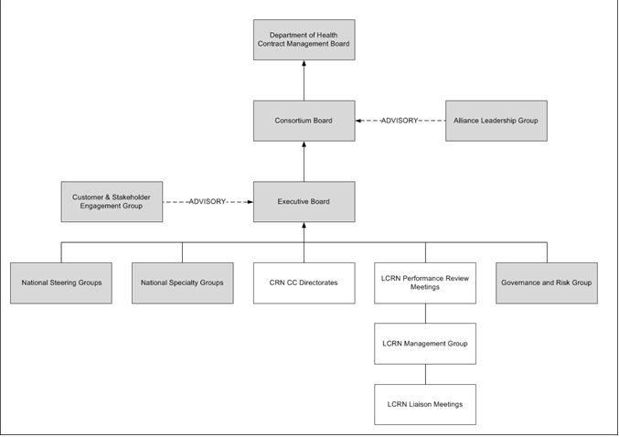

- You will support the Integrated Governance Manager with the review of the corporate governance arrangements for key boards/committees/groups to ensure they continue to fulfill their role and promote value among their members in pursuit of their purpose

- You will oversee all boards/committees/groups as they navigate through their meeting schedule. You will provide support and advice to members, problem solve as required and uniformly update the Integrated Governance Manager of your findings/recommendations.

Working Relationships and Communications

- Build and maintain strong, flexible, dynamic and effective working relationships with colleagues at all levels of the Clinical Research Network, including external stakeholders, nationally and locally.

- Act as a point of reference for internal and external queries regarding the CRN DH Enquiries, Complaints Service and Risk Register.

- Coordinate internal and external meetings, both strategic and operational, including senior national meetings, and ensure their effective administration.

- Convene and lead team meetings.

General

- Develop an awareness and understanding of the key activities of the CRN and ensure that any work being undertaken by this post is fully integrated and responsive to new developments.

- Maintain responsibility for own professional development by keeping up to date with relevant policy and key professional issues so as to be able to inform CRN colleagues and national debate as required.

- Undertake any ad hoc initiatives as required by the Corporate Governance Manager.

- The job description provides a framework for the role and should not be regarded as a definitive list of duties and responsibilities, which will develop and change over time through natural progression.

UNIVERSITY VALUES

All staff members are expected to operate in line with the university’s values and standards, which work as an integral part of our strategy and set out the principles of how we work together. More information about the university’s strategy and values is available at http://www.leeds.ac.uk/comms/strategy/

PERSON SPECIFICATION

Essential

- Proven ability of supporting the set-up of a new team.
- Proven experience of working within Corporate and Information Governance and successfully assisting in setting up governance arrangements.
- Advanced organisational skills demonstrated by proven ability to successfully manage and complete projects and initiatives on time.
- Proven experience of maintaining a corporate risk register ensuring risk assessment and mitigation.
- Experience in developing, implementing and monitoring policies, procedures and standards.
- Ability to deliver results working autonomously with little direct supervision.
- Excellent self-management skills, including ability to deliver and work to deadlines, high motivation, efficiency, responsiveness, determination and resilience, ability to work flexibly and manage competing priorities.
- Excellent interpersonal skills with proven ability to work effectively as part of a team.
- A relevant degree or a professional management qualification, or equivalent experience within the Corporate Governance field.
- Available and willing to travel frequently within the UK.

Desirable

- Experience of working for a complex, distributed national organization.
- An understanding of the UK clinical research environment, including Network and NHS structures.

BACKGROUND INFORMATION

NIHR Clinical Research Network

The National Institute for Health Research (NIHR) Clinical Research Network (CRN) makes it possible for all patients and health professionals across England to participate in relevant clinical trials. We provide the infrastructure that allows high-quality clinical research to take place in the NHS, so that patients can benefit from new and better treatments. We also help researchers to set up clinical studies quickly and effectively, we support the life-sciences industry to deliver their research programmes, we provide health professionals with research training and we work with patients to ensure their needs are at the very centre of all research activity. With annual funding of £300m and a portfolio of some 6000 clinical studies, we provide a workforce of several thousand embedded NHS staff, supported by streamlined, effective and efficient operational systems, to support the delivery of research in all clinical specialties in all NHS sectors. The NIHR CRN is formed of 15 Local Clinical Research Networks (LCRNs) that provide coverage of the whole of England, and our portfolio of studies is organised in 30 clinical research Specialties.

The NIHR CRN Coordinating Centre (CRNCC) provides national coordination and oversight of the CRN, which includes development and implementation of national CRN strategies, policies, systems, processes, frameworks and standards, and support and performance management for the LCRNs and CRN Specialties.

The Coordinating Centre is a hosted organisation jointly managed by the University of Leeds and Guy’s and St Thomas’ NHS Foundation Trust (“the CRNCC Consortium”). Some specific activities are provided by a broader Alliance of partners that includes Newcastle University, the University of Liverpool, Kings College London, Imperial College London, and PA Consulting Group.

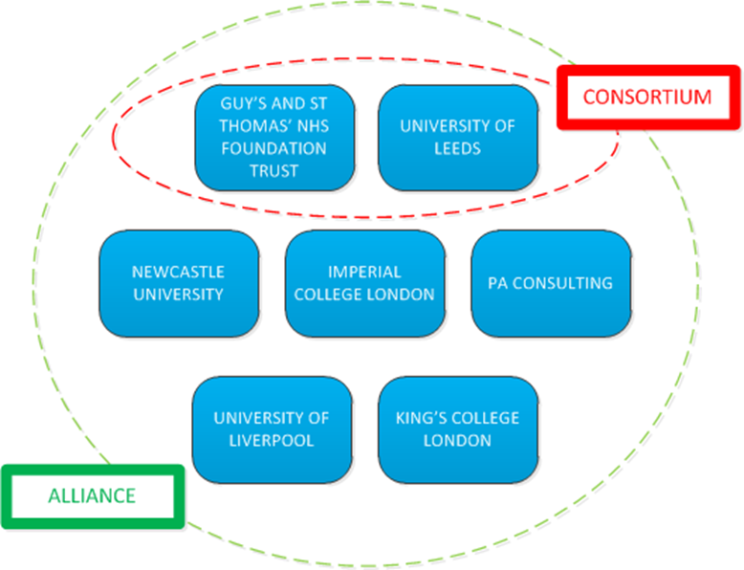

For further information about the NIHR Clinical Research Network, please visit our website: http://www.crn.nihr.ac.uk/

National Institute for Health Research

The NIHR Clinical Research Network is a key element of the National Institute for Health Research, which is funded through the Department of Health to improve the health and wealth of the nation through research. The NIHR is a large, multi-faceted and nationally distributed organisation. Together, NIHR people, facilities and systems represent the most integrated clinical research system in the world, driving research from bench to bedside for the benefit of patients and the economy.

Since its establishment, the NIHR has transformed research in the NHS. It has increased the volume of applied health research for the benefit of patients and the public, driven faster translation of basic science discoveries into tangible benefits for patients and the economy, and developed and supported the people who conduct and contribute to applied health research.

Further information on the National Institute for Health Research can be found at: www.nihr.ac.uk

University of Leeds

The University of Leeds is one of the UK’s largest, most prestigious and diverse research-intensive universities. Ranked amongst the world’s top 100 universities in the QS World rankings, and a member of the Russell Group of leading research universities, the University has an annual turnover of £587 million, over 31000 students and 7500 staff. It is now embarking on an exciting and critical period in its development, making significant investments in its infrastructure and research capability as part of a new strategic plan.

The CRN CC is hosted within the Faculty of Medicine and Health. The Faculty is at the forefront of cutting edge discovery science and translational clinical research and has a broad portfolio of programmes of study, training tomorrow’s healthcare and medical professionals. With around 1600 staff and more than 6500 students it is the largest faculty in the University of Leeds, and is one of the largest medical faculties in Europe.

Guy’s and St Thomas’ NHS Foundation Trust

With an annual turnover of £1.2 billion, GSTFT has a national and international reputation for managing and delivering a vast range of clinical research at scale, as well as for the corporate integration of research as a core business activity incorporating hosting functions and strong collaborative partnering to create a hub of research management expertise.

The Trust recognises the importance that commercial acumen and discipline brings to the long term sustainability of the organisation, especially in respect of working with complex and varied providers and identifying new revenue streams. GSTFT is a UK leader in strategic and joint ventures in healthcare delivery and as a result, the Trust now has the largest commercial directorate of any Trust within UK. The Trust’s Commercial Directorate, as the commercial arm of the organisation, works closely in support of Trust services to develop and deliver external contract income. This income generation is achieved by using the reputation, skills, capacity and location of the Trust and its staff. The Commercial Directorate builds on over 20 years' experience of delivering health services to external organisations both nationally and internationally.

University of Liverpool

The University of Liverpool is a world famous brand; it is one of only two UK Higher Education institutions to have a campus in China, has opened an innovative new campus in London and is the largest provider of wholly online degrees in Europe. Our research expertise spans a broad range of disciplines and is world leading in a number of subject areas. We have a national profile for our contribution to widening participation in UK Higher Education, ensuring that no student able to benefit from studying at a Russell Group University is deterred from applying as a result of financial constraints.

The University has ambitious plans for growth and has been pursuing a transformation agenda for a number of years. This is manifest in part in significant development of our University campus and the introduction of award winning Central Teaching Laboratories and on-campus student accommodation, a £25m investment in our libraries, £36m investment in our engineering facilities alongside a recent overhaul of Guild of Students building which has been transformed as a result of £12m investment.

Newcastle University

Newcastle upon Tyne is one of the oldest university cities in England. The University has one of the largest EU research portfolios in the UK and attracts over 20,000 students from more than 120 different countries. Teaching and research are delivered in 24 academic schools and 40 research institutes and research centres, spread across three Faculties. The university offers around 175 full-time undergraduate degree programmes in a wide range of subject areas spanning arts, sciences, engineering and medicine, together with approximately 340 postgraduate taught and research programmes across a range of disciplines.

Newcastle University has a world-class reputation for research excellence and spearheads three major societal research challenges that have a significant impact on global society: Ageing and Health, Sustainability, and Social Renewal. Newcastle has received awards for pioneering research into treating polluted water from abandoned mines, world-leading work on ageing and health and internationally renowned research into sustainable rural economies and societies.

King’s College London

King's College London offers an intellectually stimulating environment in which to work, in which staff are dedicated to the advancement of knowledge and learning, in the service of society. As a multi-faculty institution, Kings provide high-quality teaching, research and innovation across the sciences, humanities, medicine, law, dentistry, and social sciences and are a member of the Russell Group, of research intensive higher education institutions. King’s is committed to maintaining the highest standards in research and education and is the largest centre for the education of healthcare professionals in Europe, and is home to five Medical Research Council Centres spread across its three teaching hospitals.

King's is one of the top 20 universities in the world (2014/15 QS World University Rankings) and is the fourth oldest university in England and based in the heart of London, King's has more than 26,000 students from nearly 140 countries, and more than 7,000 employees.

Imperial College London

Imperial College London is a science-based university with an international reputation for excellence in teaching and research. Consistently rated amongst the world's best universities, Imperial is committed to developing the next generation of researchers, scientists and academics through collaboration across disciplines.

Located in the heart of London, Imperial is a multidisciplinary space for education, research, translation and commercialisation, harnessing science and innovation to tackle global challenges.

Generations of Imperial, staff, students and alumni have changed the world with cutting-edge innovations; from the discovery of penicillin to the world’s first invisibility cloak. Recognition of this ground-breaking work has come in the form of 14 Nobel Prizes, 81 Fellowships from the Academy of Medical Sciences, 77 from the Royal Academy of Engineering and 73 from the Royal Society.

Imperial brings together intersecting disciplines, industries and sectors across four major areas to further our understanding of the natural world, solve major engineering problems, lead the data science revolution and improve health and well-being. Emerging areas of research include the development of low-carbon technologies, stem cell therapy for stroke and how to turn light into matter.

ADDITIONAL INFORMATION

Terms and Conditions

Details of the terms and conditions of employment for all staff at the university, including information on pensions and benefits, are available on the Human Resources web pages accessible via the links on the right hand side, or at http://hr.leeds.ac.uk/policies

Disclosure and Barring Service Checks

A Disclosure and Barring Service (DBS) Check is not required for this position. However, applicants who have unspent convictions must indicate this in the ‘other personal details’ section of the application form and send details to the Recruitment Officer.

Disabled Applicants

The post will either be located in Fairbairn House on the University of Leeds campus or the central London Bridge location of the NIHR CRN. Disabled applicants wishing to review access to the building are invited to contact the department direct. Additional information may be sought from the Recruitment Officer, email disclosure@leeds.ac.uk or tel + 44 (0)113 343 1723.

Disabled applicants are not obliged to inform employers of their disability but will still be covered by the Equality Act once their disability becomes known.

Further information for applicants with disabilities, impairments or health conditions is available in the applicant guidance.

